

**A PROJECT SYNOPSIS**

ON

**“DINNER TO DOOR”**

Submitted to

**SHIVAJI UNIVERSITY, KOLHAPUR**

In partial fulfilment of the requirement for the degree of

BACHELOR OF COMPUTER APPLICATION

|  |  |  |  |
| --- | --- | --- | --- |
| **Sr.no** | **Roll no** | **Name of student** | **signature** |
| **1** | **47** | **Lohar Priyanka Santosh** |  |
| **2** | **73** | **Sawant Pooja Laxman** |  |
| **3** | **75** | **Shinde Nikhil Shashikant** |  |
| **4** | **76** | **Shinde Rohan Shivaji** |  |

Submitted By

UNDER THE GUIDANCE OF

**Mr. V. D. Chavan**

Through

**The Director**

Of

**KARMAVEER BHAURAO PATIL INSTITUTE OF MANAGEMENT** **STUDIES AND RESEARCH, SATARA.**

**Year 2021-22**

**ABSTRACT**

The purpose of Online Food Ordering System is to automate the existing manual

system by the help of computerized equipment’s and full-fledged computer software. fulfilling their requirements, so that their valuable data/information can be stored for a longer period with easy accessing and manipulation of the same. The required software and hardware are easily available and easy to work with.

Online Food Ordering System, as described above, can lead to error Free. secure, reliable and fast management system. It can assist the user to concentrate on their other activities rather to concentrate on the record keeping. Thus, it will help organization in better utilization of resources. The organization can maintain computerized records without redundant entries. That means that one need not be distracted by information that is not relevant, while being able to reach the information.

The aim is to automate its existing manual system by the help of computerized equipment’s and full-fledged computer software, fulfilling their requirements, so that their valuable data/information can be stored for a longer period with easy accessing and manipulation of the same. Basically, the project describes how to manage performance and better services for the clients.

**INTRODUCTION**

The "Online Food Ordering System" has been developed to override the problems prevailing in the practicing manual system. This software is supported to eliminate and, in some cases, reduce the hardships faced by this existing system. Moreover, this system is designed for the particular need the company to carry out operations in a smooth and effective manner.

The application is reduced as much as possible to avoid errors while entering the data. It also provides error message while entering invalid data. No formal knowledge is needed for the user to use this system. Thus, by this all it proves it is user-friendly. Online Food Ordering System, as described above, can lead to error free, secure, reliable and fast management system. It can assist the user to concentrate on their other activities rather to concentrate on the record keeping. Thus, it will help organization in better utilization of resources

**PROBLEM STATEMENT**

The Online Food Ordering System deals with placing orders of food from various restaurants. This system involves the following functionalities: 1. Collecting data: The data is collected from the customer through the application. 2. Verification of data: The data collected (food ordered) from the customer is cross verified with the specific restaurant for availability. 3. Order confirmation: The order is confirmed by sending a confirmation text to the customer. 4.Live tracker: The live tracker will help the customer track current order status. 5. Customer analytics: Based on orders placed in various regions, suggestions of similar restaurants will be given. 6. Customer feedback: The customers will be able to rate their experiences, recommend changes and improvements to the current system. 7. Modes of payment: Multiple modes of payment will be provided while ensuring safe and secure online transactions.  
  
In this system we receive orders of food from customers, confirm them with restraints, provide live tracking facilities and ensure safe money transactions. The system also provides the customer the facility of rating their experience and suggesting improvements.

**ADVANTAGES:**

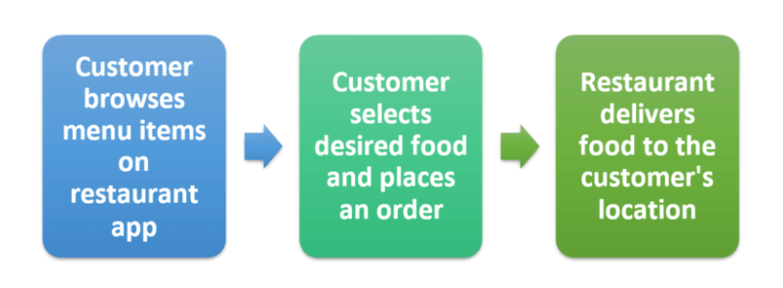

**1. Safer and healthier**

To re-open, food businesses need to set-up a shop to meet UK government health and safety regulations. Owners must maintain social distancing, use contactless ordering/payment methods and ensure surfaces are cleaned regularly.

**2. Less room for error**

One of the advantages of online food ordering for customers is that it ensures prices are accurate and there’s less room for error when it’s time to settle the bill.

**3. More customers**

As social distancing continues, online ordering and payments are becoming more accepted and expected. If your menu and payment system is hassle-free your regular customers will be recommending you to their friends, and sharing on social media.

**4. Increased customer loyalty**

Customers will choose your shop over a competitor’s if you give them a reason to keep coming back. Great products may be that reason, but you can also encourage their loyalty with a reward programme on your ordering app.

**5. Higher customer spend**

We know that a larger number of customers are now engaging with digital products and services than ever before.

Order values increase when customers order online. That’s because studying an online menu is different to standing in a queue.

**6. Highly customisable**

Menu apps are highly customisable so you can easily promote your logo, brand colours or other features that make your business unique. Plus, if you want to delete or add an item to the menu all you have to do is log in, make your changes and it’s done!

**7. Reduced costs**

With a card terminal you’re looking at a number of accompanying fees that can seriously reduce your bottom line. An ordering system for small businesses is a lot cheaper because it’s all digital, and in many cases the only cost is a small processing fee on transactions.

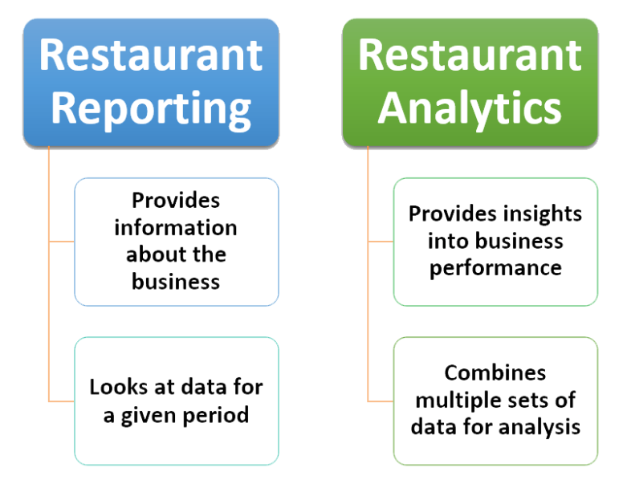

**SYSTEM ANALYSIS:**

**A DFD (Data flow diagram)**

**B ERD (Entity Requirement Diagram)**

**A DFD (Data flow diagram)**

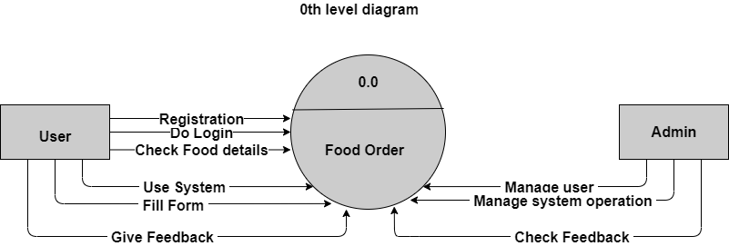

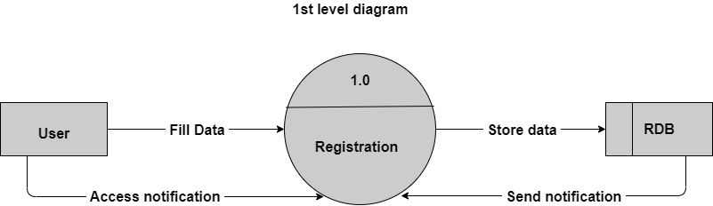

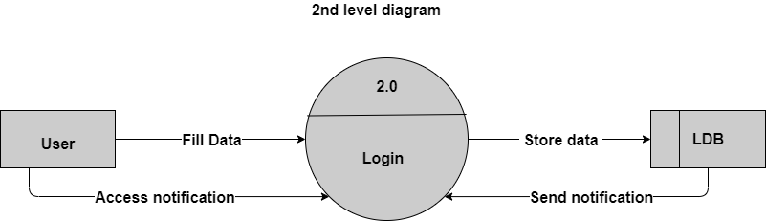

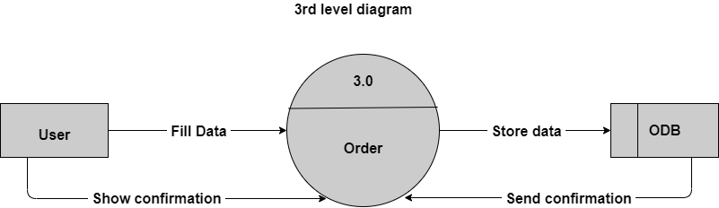

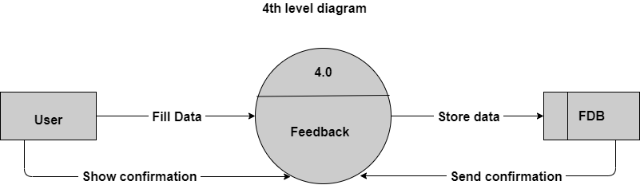

**B ERD (Entity Requirement Diagram)**

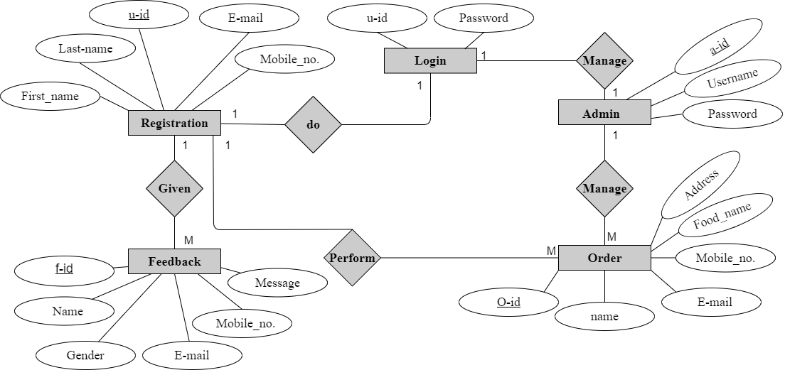

**LIMITATIONS**

Although I have put my best efforts to make the software flexible, easy to operate but limitations cannot be ruled out even by me. Though the software presents a broad range of options to its users some intricate options could not be covered into its party because of logistic and partly due to lack of sophistication. Paucity of time was also major constraint; thus, it was not possible to make the software fool proof and dynamic Lack of time also compelled me to ignore some part such as storing old result of the candidate etc.

Considerable efforts have made the software easy to operate even for the people not related to the field of computers but it is acknowledged that a layman may find it a bit problematic at the first instance. The user is provided help at each step for his convenience in working with the software.

**USER INTERFACE**

Each part of the interface interacts to be as user friendly as possible the font and buttons used will be intended to be very fast and easy to load on web pages. The pages will be kept light in space so that it won’t take long time for the page to load.

**Hardware interface:**

Processor: - Ryzen, Intel.

RAM: - 2 GB (minimum)

**Software interface:**

Operating system: - windows, Linux, mac OS

Programming language: - Html, CSS, Java

**FUTURE SCOPE OF THE PROJECT:**

In a nutshell, it can be summarized that the future scope of the project circles around maintaining information regarding. We can add printer in future We can give more advance software for Online Food Ordering System including more facilities We will host the platform on online servers to make it accessible worldwide Integrate multiple load balancers to distribute the loads of the system Create the master and slave database structure to reduce the overload of the database queries Implement the backup mechanism for taking backup of codebase and database. On regular basis on different servers

The above-mentioned points are the enhancements which can be done to increase the applicability and usage of this project. Here we can maintain the records of Food and Item Category Also, as it can be seen that now-a-days the players are versatile, i.e., so there is a scope for introducing a method to maintain the Online Food Ordering System Enhancements can be done to maintain all the Food, Item Category, Shopping Cart Customer.

We have left all the options open so that if there is any other future requirement in the system by the user.

**CONCLUSION**

An online food ordering system is developed where the customers can make an order for the food and avoid the hassles of waiting for the order to be taken by the waiter. Using the application, the end users register online, read the E-menu card and select the food from the e-menu card to order food online. Once the customer selects the required food item the chef will be able to see the results on the screen and start processing the food. This application nullifies the need of a waiter or reduces the workload of the waiter. The advantage is that in a crowded restaurant there will be chances that the waiters are overloaded with orders and they are unable to meet the requirements of the customer in a satisfactory manner. Therefore, by using this application, the users can directly place the order for food to the chef online.